ITEM DETAILS
Name of Item | Inter-War Residential Flats Building
Other Name/s  Former Name/s | 40 Flood Street, Bondi
Item type | Built
Item group | Flat Building
Item category | Flat
Area, Group, or Collection Name | Unknown
Street number | 40
Street name | Flood Street
Suburb/town | Bondi |  |  |  |  | Postcode |  |  | 2026
Local Government Area/s | Waverley
Property description | SP 11638
Location - Lat/long | Latitude | -33.892239 |  | Longitude | 151.259291
Location - AMG (if no street address) | Zone |  |  | Easting |  |  |  | Northing
Owner | Private
Current use | Residential
Former Use | Residential
Statement of significance | 40 Flood Street, Bondi, is a fine and intact example of a three-storey Inter-War Functionalist/Streamlined Moderne flat building in a suburban setting that is part of a group of flat buildings in Flood Street. It demonstrates the redevelopment of the Angelsea Estate with flats in the Inter-War period.  It also represents the development of Inter-War flat buildings, an important phase in the history of Waverley, which represents the 1920s-1930s development boom, a prominent period of economic prosperity and speculative development in Waverley associated with the changing demographics with a shift to living in flats.
Level of Significance | National |  | State |  |  |  | Local

DESCRIPTION
Designer

Builder/ maker | T.W. Liversey of 55 Captain Pipers Road, Vaucluse.
Physical Description | 40 Flood Street, Bondi, is a three-storey symmetrical, face-brick flat building with a hipped roof that dates from the Inter-War period (c1939).  The building displays features of the Inter-War Functionalist /Streamlined Moderne style with semi-circular cantilevered balconies, fenestration in horizontal bands, with horizontal glazing bars, horizontal banding in brickwork and face-brick walls.  The building is setback 7m from the street on a large site, approximately 16 metres wide, that has been subdivided in a suburban setting retained much of its historic context. The site has a fence of iron palisade on a brick plinth approximately 1.5 metres high, which detracts from the setting of the place, and a shared side driveway accessing a rear garage and parking area which dates from the Inter-War period.  The site is sparsely landscaped and features a path and lawn. The mature street trees provide an appropriate landscaped setting for the building. The floor plan provides 4 flats per floor with a side entry (Type 2 in the Waverley Inter-War Flats study). The building is in good condition and highly intact.  Elements impacting upon the integrity of the site include a palisade fence on an early low brick fence.
Physical condition  and  Archaeological potential | The building appears to be in good condition
Construction years | Start year | 1938 | Finish year | 1939 | Circa
Modifications and dates

HISTORY
Historical notes | The site of 40 Flood Street, Bondi, was part of land granted to Michael Woolley in 1839, and subdivided as the Anglesea Estate, and consolidated by Thomas Dickson from 1880 (PA 7062). The site is part of Lots 47 and 32 of this estate. The 1892 Detail Survey shows an early residence (now demolished) in this location fronting Flood Street (Waverley Sheet 18, SLNSW). Plans from 1938/1939 show the proposed block of 12 flats and 5 garages for Tessoriero Bros of Bondi Road (99473-5, 298/1938). No architect is recorded, however, the builder is recorded as T.W. Liversey of 55 Captain Pipers Road, Vaucluse. The cost of work was noted as 8000 pounds (Construction, Wed 26 Jul 1939 p2, Building and Works Approved).

THEMES
 | National historical theme | 4 Building settlements, towns and cities  8 Developing Australia’s Cultural Life
 | State  historical theme | Accommodation  Domestic life  Creative endeavour
 | Local  historical theme | Flats and Bungalows  Speculation and Subdivision

Assessment
A: Historical Significance | The site of 40 Flood Street, Bondi has historical significance at a local level as it demonstrates the redevelopment of the Angelsea Estate with flats in the Inter-War period.  40 Flood Street, Bondi has historical significance at a local level as it represents the development of Inter-War flat buildings, an important phase in the history of Waverley which represents the 1920s-1930s development boom, a prominent period of economic prosperity and speculative development in Waverley associated with the changing demographics with a shift to living in flats.
B: Associative | To date no historic association has been identified.
C: Aesthetic significance | 40 Flood Street, Bondi, has aesthetic significance at a local level as a fine and intact example of an Inter-War Functionalist /Streamlined Moderne flat building in a suburban setting that is part of a group of flat buildings.  The building shows an accomplished use of Inter-War Functionalist / Streamlined Moderne style which features semi-circular cantilevered balconies, fenestration in horizontal bands, with horizontal glazing bars, horizontal banding in brickwork and face brick walls.
D: Social significance | To date no social, cultural, and spiritual significance has been identified.
e) Technical/  Research significance | To date that no technical significance has been identified.
f) Rarity | To date the research indicates 40 Flood Street, Bondi is not rare.
g) Representative-ness | 40 Flood Street, Bondi has representative significance at a local level as a fine and intact example of a three-storey Inter-War flat building in a suburban setting, that is part of a group of flat buildings in Flood Street.
Integrity | The building is highly intact.

HERITAGE LISTINGS
Heritage listing/s | Draft Waverley LEP 2012

INFORMATION SOURCES
Type | Author/Client | Title | Year | Repository
 | Waverley Council | Waverley Heritage Policy | 2007
 | Waverley Council | Waverley Heritage Study | 1993
 | Perumal Murphy Pty Ltd | Waverley Heritage Study | 1990
 |  | Waverley Detail Survey, Sheet 18 | 1892 | State Library NSW
 |  | 99473-5, 298/1938 | 1938/  1939 | NSW Land Registry Services
 |  | Construction, Wed 26 Jul 1939 p2, Building and Works Approved | 1939

RECOMMENDATIONS
Recommendations

SOURCE OF THIS INFORMATION
Name of study or report | Heritage Policy by Waverley Council reviewed by Architectural Projects 2023 |  | Year of study or report
Item number in study or report

Author of study or report
Inspected by
NSW Heritage Manual guidelines used? |  |  |  | Yes |  | No
This form completed by |  |  |  | Date

IMAGES

Image caption | 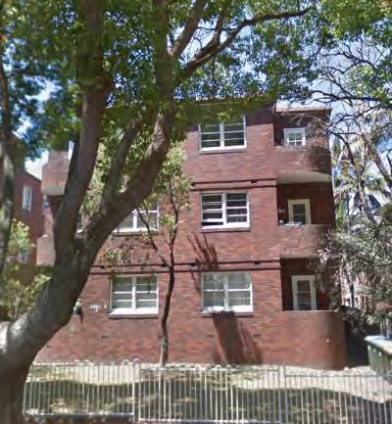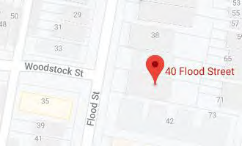
Image year |  | Image by | Google Maps | Image copyright holder

Image caption | 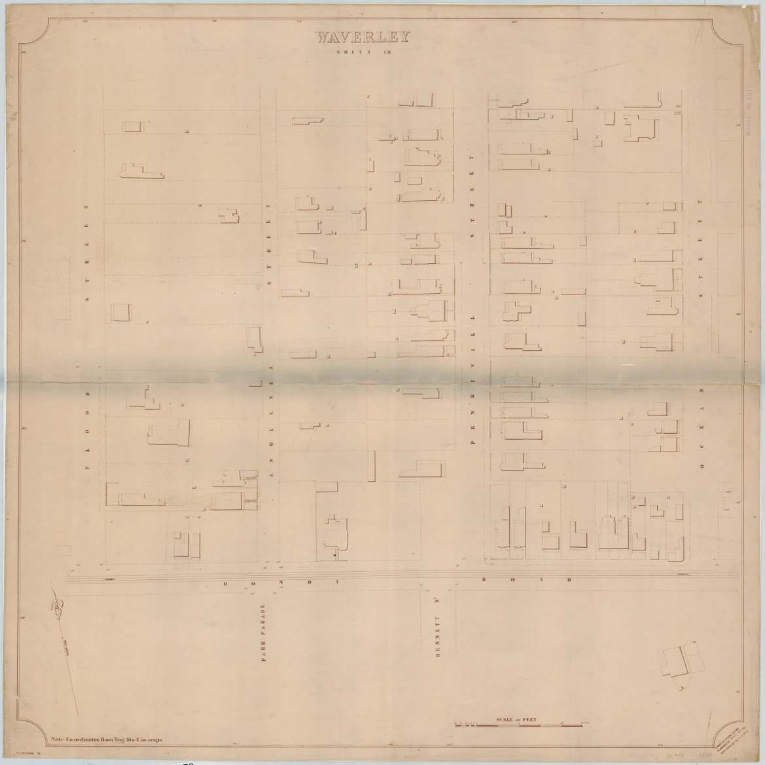
Image year | 1892 | Image by | State Library of New South Wales | Image copyright holder

Image caption | 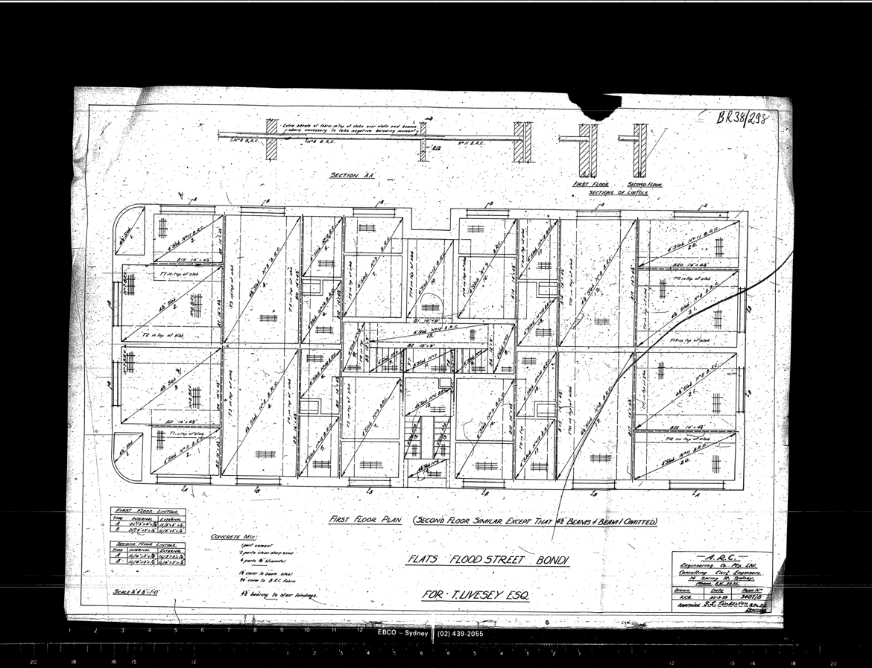
Image year | 1938 | Image by | Waverley Council | Image copyright holder

Image caption | 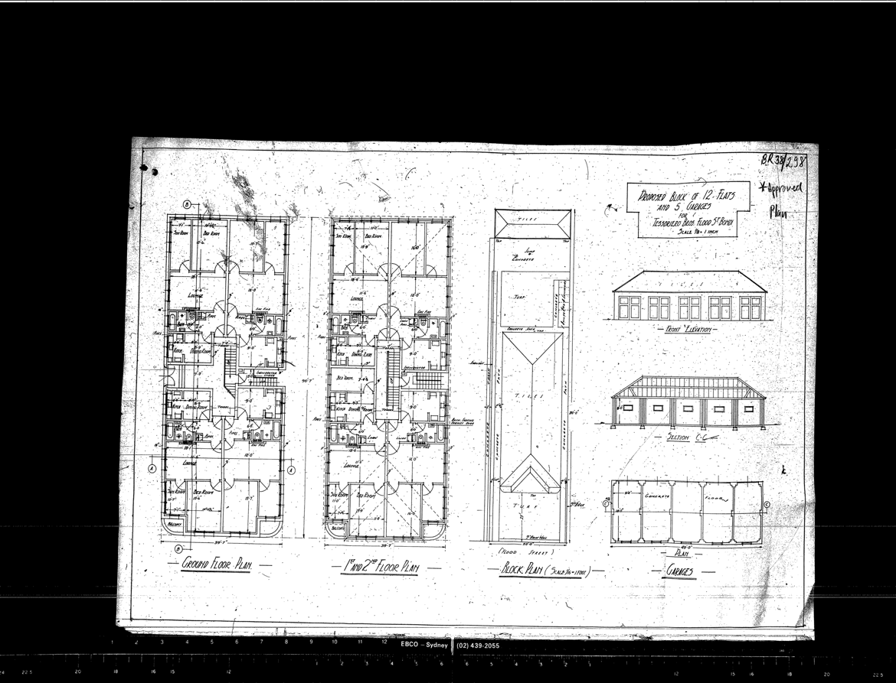
Image year | 1938 | Image by | Waverley Council | Image copyright holder

